ØØ Explanation :
- We are given two BCD numbers at memory locations D000 H and D001 H. Let these numbers be 02 H and 09 H.
- We have to add the byte at memory location D000 H (02 H) with the byte at memory location D001 H (09 H).
- Initially we will store the first number in the accumulator.
- Using ADD instruction add the two contents. Result of addition will be stored in the A register.
- Using DAA adjust the result to valid BCD number.
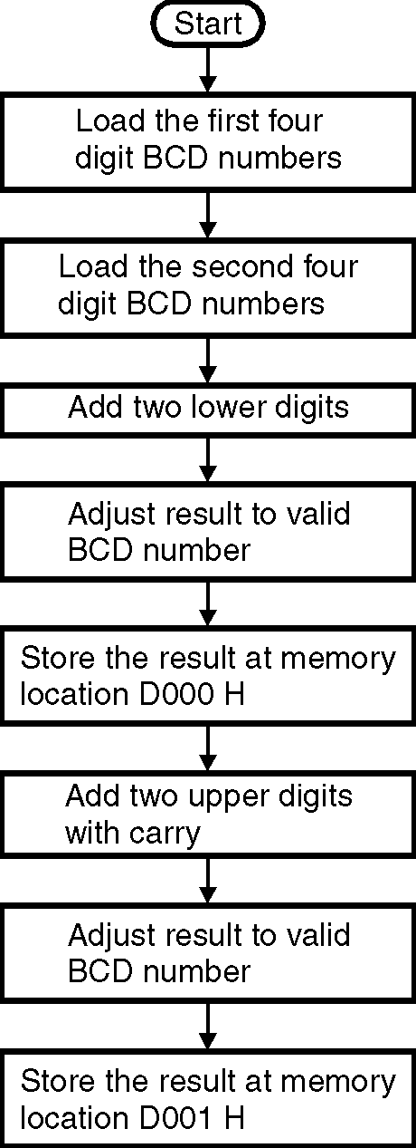
- Store the result at memory location D002 H.
For example : | D000 H = 02 H |  | 02 H
 | D001 H = 09 H | + | 09 H
 | DAA |  | 0B H (invalid BCD)
 |  | + | 06 H
 |  |  | 11 H ( valid BCD)
➢➢ Algorithm :
Step I : Start
Step II : Get the first number in A register.
Step III : Get the second number in memory.
Step IV : Add the two numbers.
Step V : Store the result at memory location D002 H
Step VI : Stop
➢➢ Flowchart : Refer flowchart 13.
Program :
Instruction Comment
LXI H, D000 H ; HL points to the memory
; location D000 H
MOV A,M ; Get the contents of location
; D000 H into the accumulator.
INX H ; Increment HL to point to next memory
; location i.e. D001H Flowchart 13
ADD M ; A = A +M i.e. compute the addition
DAA ; Convert the HEX to valid BCD result.
INX H ; Increment HL to point to next memory
; location i.e. D002H
MOV M, A ; Store the result at memory location
; D002 H
HLT ; Terminate the execution of program

